Tail dependence: NZDUSD and EURGBP
Method 19 / daily log returns / alpha=0.05 / Alpari D1 full available history

Study setup
Logical pair: NZDUSD , EURGBP
Broker symbols: NZDUSD_i , EURGBP_i
Snapshot: 2026-11-03_majors_alpari_D1
Timeframe: D1
Matched return window: 1999-01-06 to 2026-11-02 (UTC bar dates)
Matched return count n: 7183
Dropped unfinished last bar dated 2026-11-03 UTC after a tick-volume check against the prior complete day.
Uniforms: ranks/(n+1); alpha=0.05
Complete matched rows (Excel): NZDUSD-EURGBP_Tail_D1.xlsx
Complete matched rows (HTML table): NZDUSD-EURGBP_Tail_D1_data.html

Method carried forward
Tail dependence counts how often both legs sit in an extreme uniform tail together. Matched daily log returns of close, ln(close_t / close_t-1), become u_i = rank(x_i)/(n+1) and v_i = rank(y_i)/(n+1). At alpha=0.05, lower L_hat = (# u<=alpha and v<=alpha) / (# conditioning leg <= alpha); upper uses >= 1-alpha. Both conditioning directions are reported with numerator and denominator counts. Quotes are not inverted. L_hat(0.05) is a finite-sample frequency, not the asymptotic lambda. Same-sample Pearson r is a side check. This is not causation and not a trading signal.

Results
tail | cond | L_hat | num | denom
lower | EURGBP | 0.139276 | 50 | 359
lower | NZDUSD | 0.139276 | 50 | 359
upper | EURGBP | 0.119777 | 43 | 359
upper | NZDUSD | 0.119777 | 43 | 359
Pearson r on returns: 0.037186

Conclusion
Over 7183 matched daily rows for NZDUSD and EURGBP at alpha=0.05, lower L_hat conditioning on EURGBP is 0.1393 (50/359); conditioning on NZDUSD is 0.1393. Upper L_hat conditioning on EURGBP is 0.1198; on NZDUSD is 0.1198. Pearson r = 0.0372. These are finite-sample frequencies, not asymptotic lambda and not a trading signal.

Charts
Daily closes

Daily log returns

Uniforms with alpha lines
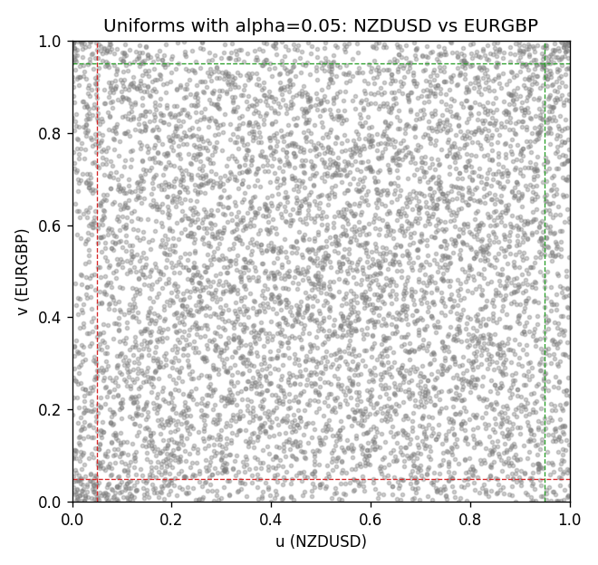

Data report
Every matched row is stored in the sibling Excel workbook named NZDUSD-EURGBP_Tail_D1.xlsx, including u and v. Embedding all rows as a Word table is impractical; this file holds column summaries and the first and last 15 matched rows.
Columns: time, NZDUSD_open, EURGBP_open, NZDUSD_high, EURGBP_high, NZDUSD_low, EURGBP_low, NZDUSD_close, EURGBP_close, NZDUSD_tick_volume, EURGBP_tick_volume, NZDUSD_spread, EURGBP_spread, NZDUSD_real_volume, EURGBP_real_volume, NZDUSD_log_return, EURGBP_log_return, u, v
Column summaries (matched calculation rows)
column | count | mean | std | min | 25% | 50% | 75% | max
NZDUSD_open | 7183 | 0.65646991 | 0.10818219 | 0.3913 | 0.591455 | 0.6684 | 0.72495 | 0.88218
EURGBP_open | 7183 | 0.78694248 | 0.0966971 | 0.5734 | 0.68755 | 0.83389 | 0.86522 | 0.9769
NZDUSD_high | 7183 | 0.66038812 | 0.10867344 | 0.3961 | 0.5949 | 0.67204 | 0.729365 | 0.88421
EURGBP_high | 7183 | 0.7900202 | 0.09707133 | 0.5789 | 0.6896 | 0.8369 | 0.8681 | 0.9799
NZDUSD_low | 7183 | 0.65278196 | 0.10777661 | 0.3897 | 0.58816 | 0.6642 | 0.720985 | 0.87988
EURGBP_low | 7183 | 0.78424251 | 0.0965143 | 0.5682 | 0.6855 | 0.83166 | 0.86287 | 0.9661
NZDUSD_close | 7183 | 0.65654354 | 0.10817679 | 0.3907 | 0.59181 | 0.6685 | 0.72502 | 0.8822
EURGBP_close | 7183 | 0.78698724 | 0.09669475 | 0.5735 | 0.68775 | 0.83395 | 0.86536 | 0.977
NZDUSD_tick_volume | 7183 | 68736.568 | 123152.54 | 16 | 5594.5 | 33901 | 58513.5 | 1127682
EURGBP_tick_volume | 7183 | 87133.158 | 145499.84 | 154 | 6553 | 44358 | 81413 | 1424684
NZDUSD_spread | 7183 | 30.260755 | 25.633067 | 0 | 9 | 17 | 40 | 80
EURGBP_spread | 7183 | 21.328832 | 19.122264 | 0 | 4 | 13 | 40 | 50
NZDUSD_real_volume | 7183 | 1.6708354e+10 | 8.49951e+10 | 0 | 0 | 0 | 0 | 2.705649e+12
EURGBP_real_volume | 7183 | 2.7872287e+10 | 1.3521454e+11 | 0 | 0 | 0 | 0 | 3.5726265e+12
NZDUSD_log_return | 7183 | 1.073e-05 | 0.0076464 | -0.07027433 | -0.00425909 | 0.00022967 | 0.00458236 | 0.05966839
EURGBP_log_return | 7183 | 2.33e-05 | 0.00487088 | -0.03067367 | -0.00262163 | -9.879e-05 | 0.002558 | 0.06075387
u | 7183 | 0.5 | 0.28865504 | 0.0001392 | 0.2500696 | 0.5 | 0.7499304 | 0.9998608
v | 7183 | 0.5 | 0.28865499 | 0.0001392 | 0.2500696 | 0.5 | 0.7499304 | 0.9998608
First 15 matched rows (selected columns)
time | NZDUSD_log_return | EURGBP_log_return | u | v
1999-01-06 | 0.0020455609 | -0.013303338 | 0.61483853 | 0.0080734967
1999-01-07 | 0.0062963171 | 0.011051402 | 0.82628062 | 0.98218263
1999-01-08 | -0.00055396548 | -0.004943862 | 0.45155902 | 0.11915367
1999-01-11 | 0.010290425 | -0.0012752393 | 0.93012249 | 0.37444321
1999-01-12 | -0.0053157489 | 0.0033970309 | 0.20601336 | 0.80233853
1999-01-13 | -0.0099742238 | 0.00042381861 | 0.079064588 | 0.55025056
1999-01-14 | -0.00018564931 | -0.0019793588 | 0.47522272 | 0.30790646
1999-01-15 | -0.00074294208 | -0.0076715819 | 0.44084076 | 0.048580178
1999-01-18 | -0.0018597736 | 0.00071280921 | 0.37346882 | 0.58059577
1999-01-19 | 0.0018597736 | -0.0014261269 | 0.60370267 | 0.36121938
1999-01-20 | 0.0040793678 | 0.0019960086 | 0.72543151 | 0.70601336
1999-01-21 | 0.0040627941 | -0.00071240297 | 0.72424833 | 0.43179287
1999-01-22 | -0.012051689 | -0.0017118406 | 0.052895323 | 0.33143096
1999-01-25 | -0.0035504102 | -0.0054402425 | 0.28646993 | 0.1011971
1999-01-26 | 0.0072741158 | -0.00057438255 | 0.86066258 | 0.44877506
Last 15 matched rows (selected columns)
time | NZDUSD_log_return | EURGBP_log_return | u | v
2026-10-13 | 0.0047326165 | 0.00020130374 | 0.7577951 | 0.53062361
2026-10-14 | -0.0037306483 | 0.0011241873 | 0.27742205 | 0.62319042
2026-10-15 | 0.0047634855 | -0.00087557391 | 0.75932628 | 0.41244432
2026-10-16 | 0.0057501001 | -0.0020380844 | 0.80526169 | 0.30275612
2026-10-19 | 0.0018917133 | -0.00056950988 | 0.60648664 | 0.44947105
2026-10-20 | 0.0037199341 | -0.0035906254 | 0.70629176 | 0.18582962
2026-10-21 | 0.0030923331 | -0.00140647 | 0.67497216 | 0.36261136
2026-10-22 | -0.0033035227 | -0.0018743924 | 0.29607461 | 0.31681514
2026-10-23 | 0.0030929853 | 0.00082421033 | 0.67511136 | 0.59242762
2026-10-26 | -0.0028993932 | 0.00013133309 | 0.31667595 | 0.52199332
2026-10-27 | -0.00026399852 | -0.0019957343 | 0.4686804 | 0.30665367
2026-10-28 | -0.0097283914 | 0.00066967224 | 0.084075724 | 0.57739421
2026-10-29 | 0.00062190714 | -0.0011722209 | 0.52589087 | 0.38376949
2026-10-30 | 0.00019537668 | -0.0024205543 | 0.49846882 | 0.26795657
2026-11-02 | -0.0025962955 | 0.00089940465 | 0.33198775 | 0.60077951

